MINIMAX ALGORITHM:

PROGRAM:
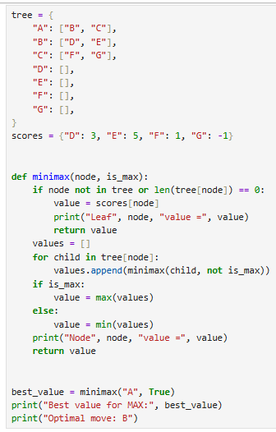
OUPUT:
